|  |  |
| --- | --- |
| **Lab Exercises** | |
| 1. | Write a HTML program for the demonstration of Lists.   1. Unordered List 2. Ordered List 3. Definition List 4. Nested List |
| 2. | Write a HTML program for demonstrating Hyperlinks.  a. Navigation from one page to another.  b.Navigation within the page. |
| 3. | Write a HTML program for time-table using tables. |
| 4. | Write a HTML program to develop a static Home Page using frames. |
| 5. | Write a HTML program to develop a static Registration Form. |
| Write a HTML program to develop a static Login Page. |
| 6. | Write HTML for demonstration of cascading stylesheets.   1. Embedded stylesheets. 2. External stylesheets. 3. Inline styles. |
| 7. | Write a javascript program to validate USER LOGIN page. |
| Write a javascript program for validating REGISTRATION FORM |
| 8. | a. Write a program for implementing XML document for CUSTOMER DETAILS. |
| b. Write an internal Document Type Definition to validate XML for CUSTOMERDETAILS? |
| c. Write an external Document Type Definition to validate XML for CUSTOMERDETAILS? |
| 9. | Write an XML for person information and access the data using XSL. |
| 10. | Write an XML for student information and access second students data using DOM. |

**1. Write a HTML program for the demonstration of Lists.**

**a. Unordered List**

**b. Ordered List**

**c. Definition List**

**d..Nested List**

<!DOCTYPE html>

<html lang="en">

<head>

<meta charset="UTF-8">

<title>Unordered List</title>

</head>

<body>

<h1>Unordered List</h1>

<ul>

<li>Item 1</li>

<li>Item 2</li>

<li>Item 3</li>

</ul>

</body>

<head>

<title>Ordered List</title>

</head>

<body>

<h1>Ordered List</h1>

<ol>

<li>First Item</li>

<li>Second Item</li>

<li>Third Item</li>

</ol>

</body>

<head>

<title>Definition List</title>

</head>

<body>

<h1>Definition List</h1>

<dl>

<dt>HTML</dt>

<dd>Hypertext Markup Language</dd>

<dt>CSS</dt>

<dd>Cascading Style Sheets</dd>

<dt>JavaScript</dt>

<dd>Scripting language for web development</dd>

</dl>

</body>

<head>

<title>Nested List</title>

</head>

<body>

<h1>Nested List</h1>

<ul>

<li>Item 1

<ul>

<li>Sub-item 1</li>

<li>Sub-item 2</li>

</ul>

</li>

<li>Item 2</li>

</ul>

</body>

</html>

**OUTPUT :**

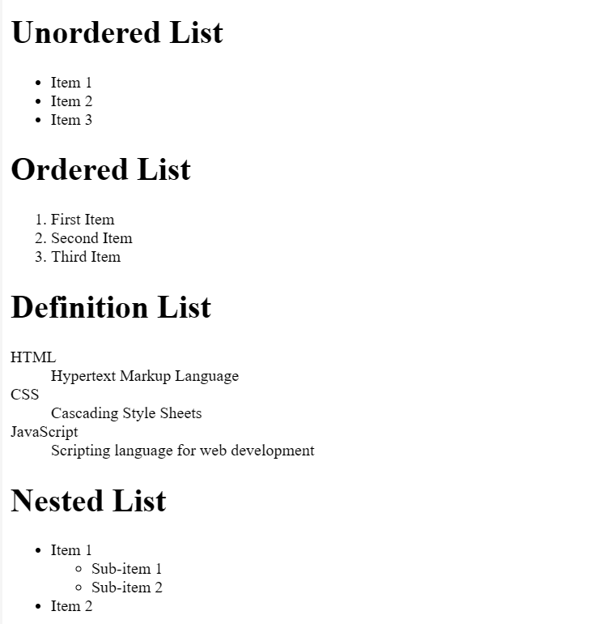

**2. Write a HTML program for demonstrating Hyperlinks.**

**a. Navigation from one page to another.**

**b.Navigation within the page.**

<!DOCTYPE html>

<html>

<head>

<title> Hyperlinking </title>

</head>

<body>

<h1> Navigation from one page to another </h1>

<a href = "https://www.scuba.com/blog/wp-content/uploads/2010/02/bioluminescent-plankton-shutterstock_2225102661.jpg" target = "_blank"> BIOLUMNISCENSE </a>

<h1> Navigation within the same page </h1>

<a href = "https://media.newyorker.com/photos/635af9797e928caf8417886c/16:9/w_1280,c_limit/Shouts-Kanye-Illuminati.jpg"> ILLUMINATI </a>

</body>

</html>

**OUTPUT :**

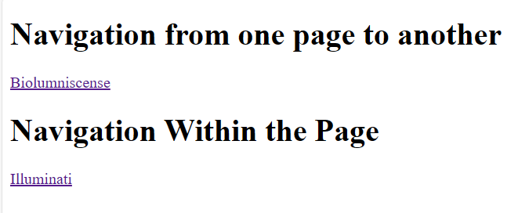  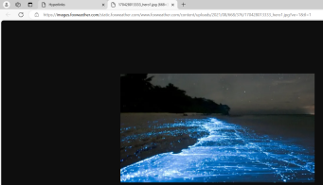

**3. Write a HTML program for time-table using tables.**

<html>

<head>

<title> HTML prog-3 </title>

</head>

<body>

<table border = '2' width = 60% height = 60%>

<tr>

<th colspan ='9'>Time Table</th>

<tr>

<th rowspan = '9' > Days </th>

<tr>

<th> MON </th>

<td> AI </td>

<td> M4 </td>

<td> DBMS </td>

<td> AI(TTL) </td>

<th rowspan = '6' > LUNCH </th>

<td> WEB Lab </td>

<td> WEB Lab </td>

<td> Sports/Yoga </td>

</tr>

<tr>

<th> TUE </th>

<td> DBMS </td>

<td> AI </td>

<td> M4 </td>

<td> ML </td>

<td> APTI </td>

<td> KAN </td>

<td> ML </td>

</tr>

<tr>

<th> WED </th>

<td> DBMS </td>

<td> M4 </td>

<td> ML </td>

<td> APTI </td>

<td> Prof.Elect </td>

<td> Prof.Elect </td>

<td> AI(TTL) </td>

</tr>

<tr>

<th> THURS </th>

<td> MLL - B2 </td>

<td> MLL - B2 </td>

<td> AI </td>

<td> APTI </td>

<td> M4 </td>

<td> Prof.Elect </td>

<td> Bio </td>

</tr>

<tr>

<th> FRI </th>

<td> ML </td>

<td> APTI </td>

<td> Prof.Elect </td>

<td> Prof.Elect </td>

<td> ML </td>

<td> Career Pathway </td>

<td> MLL - B1 </td>

</tr>

<tr>

<th> SAT </th>

<td> DBMS LAB </td>

<td> DBMS LAB </td>

<td> UHV </td>

<td> Prof.Elect </td>

<td> Mentoring </td>

</tr>

<tr>

</table>

</body>

</html>

**OUTPUT :**

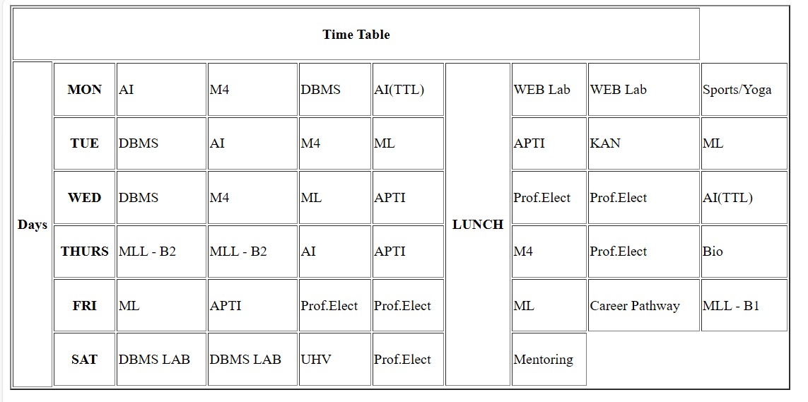

**4. Write a HTML program to develop a static Home Page using frames.**

<!DOCTYPE html>

<html>

<head>

<title>Home Page with Frames</title>

</head>

<frameset cols="25%,50%">

<frame src="siddebar.html">

<frame src="content.html">

</frameset>

</html>

Siddebarm.html:

<!DOCTYPE html>

<html lang="en">

<head>

<meta charset="UTF-8">

<title>Sidebar</title>

</head>

<body>

<h2>Sidebar</h2>

<ul>

<li><a href="content.html" target="content">Home</a></li>

</ul>

</body>

</html>

Content.html:

<!DOCTYPE html>

<html lang="en">

<head>

<meta charset="UTF-8">

<title>Content</title>

</head>

<body>

<h1>Welcome to the Home Page</h1>

<p>Content for the home page.</p>

</body>

</html>

**OUTPUT :**

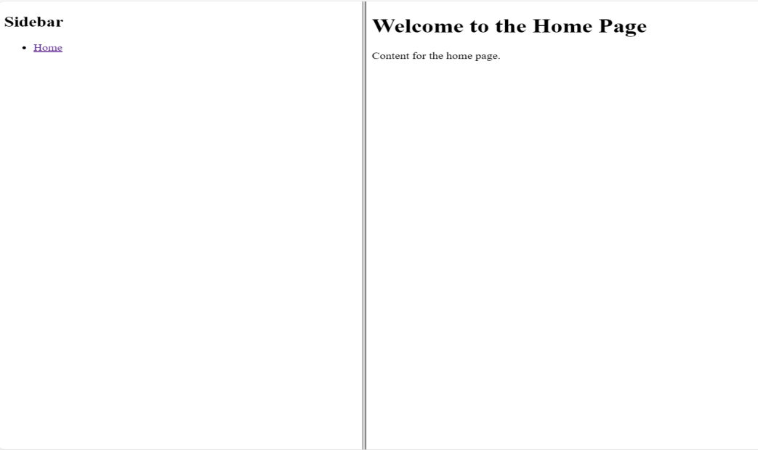

**5a. Write a HTML program to develop a static Registration Form.**

<html>

<head>

<title>Login form</title>

</head>

<body>

<center <h1> Login Form</h1></center>

<form>

<div class = "container">

<label> Username </label>

<input type = "text" placeholder = "username" name = "Username"required>

<br>

<br>

<label>Password</label>

<input type = "text" placeholder = "password" name = "Password"required><br>

<br>

<buttontype = "submit" >Login</button>

<input type = "checkbox" checked = "checked">Remember me

<button type = "button" class = "cancelbtn">Cancel</buttton>

Forgot<a href = ""> password?</a>

</div>

</form>

</body>

</html>

**OUTPUT :**

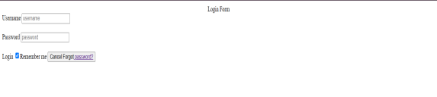

**5b. Write a HTML program to develop a static Login Page.**

<html>

<head>

<head>

<style>

body{

font-family: Calibri, Helvetica, sans-serif;

background-color: pink;

}

.container {

padding: 50px;

background-color: lightblue;

}

input[type=text], input[type=password], textarea {

width: 100%;

padding: 15px;

margin: 5px 0 22px 0;

display: inline-block;

border: none;

background: #f1f1f1;

}

input[type=text]:focus, input[type=password]:focus {

background-color: orange;

outline: none;

}

div {

padding: 10px 0;

}

hr {

border: 1px solid #f1f1f1;

margin-bottom: 25px;

}

.registerbtn {

background-color: #4CAF50;

color: white;

padding: 16px 20px;

margin: 8px 0;

border: none;

cursor: pointer;

width: 100%;

opacity: 0.9;

}

.registerbtn:hover {

opacity: 1;

}

</style>

</head>

<br>

<br>

<form>

<centre> <h1>Student Registration Form</h1></center>

<label>Firstname </label>

<input type= "text" name= "firstname" size= 15/><br><br>

<label>Middlename </label>

<input type= "text" name= "middlename" size= 15/><br><br>

<label>Lastname </label>

<input type= "text" name= "lastname" size= 15/><br><br>

<label>Course</label>

<select>

<option value = "Course"/>Course<option>

<option value = "BE"/>BE<option>

<option value = "BCA"/>BCA<option>

<option value = "BCOM"/>BCOM<option>

<option value = "MBBS"/>MBBS<option>

<option value = "Architecture"/>Architecture<option>

<option value = "MCA"/>MCA<option>

<option value = "other"/>other<option>

<br>

<br>

</select>

<label>Gender</label>

<input type ="radio" name="male"/><br><br>

<input type ="radio" name="female"/><br><br>

<input type ="radio" name="other"/><br><br>

<label>Phonenumber</label>

<input type="text" name= "country code" value= "+91" size = "2"/><br>

<input type="text" name= "phone " size = "10"/><br>

<br>

<br>

<label>Address</label>

<br>

<textarea cols = "80"rows = "5" value = "address">

</textarea>

<label> E-mail</label>

<input type= "email" id= "email" name= "email"/><br>

<label>Passsword</label>

<input type= "password" id = "pass" name = "pass"/>

<br>

<label>Retype passsword</label>

<input type= "password" id = "pass" name = "pass"/>

<input type= "button" value = "Submit"/>

<br>

</form>

</body>

</html>

**OUTPUT :**

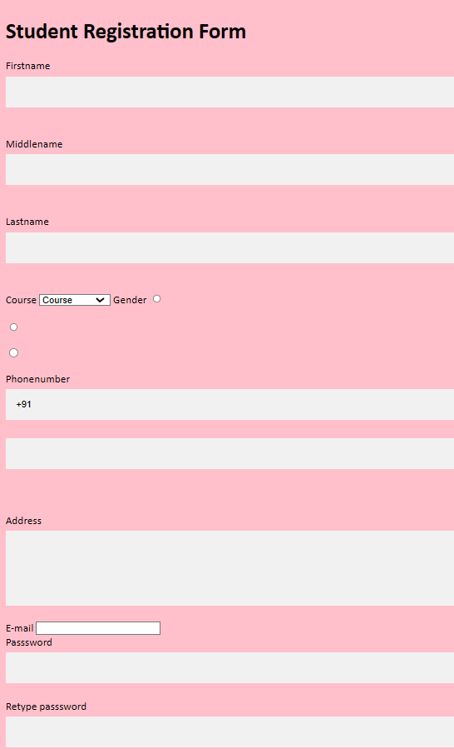

**6. Write HTML for demonstration of cascading stylesheets.**

**a. Embedded stylesheets.**

**b. External stylesheets.**

**C. Inline styles.**

<html>

<head>

<title> HTML using CSS</title>

</head>

<body>

<h1 style="color: blue;

font-style: italic;

text-align: center;

font-size: 50px;

padding-top: 25px;">HTML using inline CSS</h1>

</body>

<h2> HTML using embedded / internal CSS</h2>

<style>

body {background-color : lavender;}

h1 {color: blue;

font-style: italic;

text-align: center;

font-size: 50px;

padding-top: 25px;">HTML using internal CSS</h1>

</html>

**OUTPUT :**

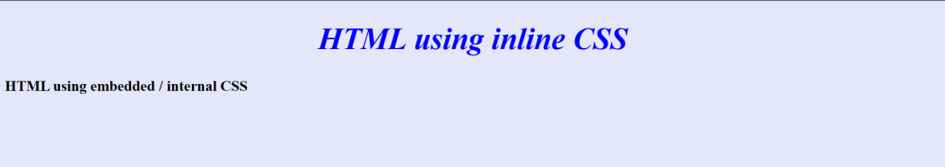

<!DOCTYPE html>

<html lang="en">

<head>

<meta charset="UTF-8">

<title>Embedded Stylesheet</title>

<style>

body {

background-color: #f0f0f0;

color: #333;

}

h1 {

color: #007BFF;

}

p {

font-size: 18px;

}

</style>

</head>

<body>

<h1>Embedded Stylesheet</h1>

<p>This is a paragraph with embedded CSS.</p>

</body>

</html>

**OUTPUT :**

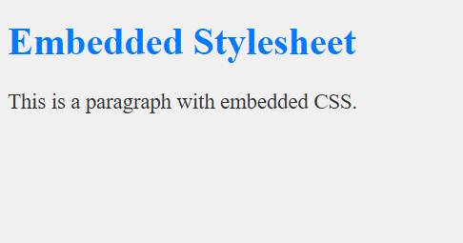

<!DOCTYPE html>

<html lang="en">

<head>

<meta charset="UTF-8">

<title>External Stylesheet</title>

<link rel="stylesheet" href="styles.css">

</head>

<body>

<h1>External Stylesheet</h1>

<p>This is a paragraph with external CSS.</p>

</body>

</html>

**OUTPUT :**

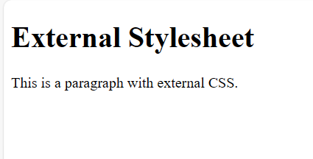

**7a. Write a javascript program to validate USER LOGIN page.**

<!DOCTYPE html>

<html lang="en">

<head>

<meta charset="UTF-8">

<title>Login Page</title>

<style>

.error {

color: red;

}

</style>

<script>

function validateLoginForm() {

var username = doc.getElementById('username').value.trim();

var password = doc.getElementById('password').value.trim();

var gender = doc.querySelector('input[name="gender"]:checked');

doc.getElementById('username-error').textContent = username === '' ? 'Username is required' : '';

doc.getElementById('password-error').textContent = password === '' ? 'Password is required' : '';

doc.getElementById('gender-error').textContent = !gender ? 'Please select your gender' : '';

return username !== '' && password !== '' && gender;

}

</script>

</head>

<body>

<h2>Login Page</h2>

<form onsubmit="return validateLoginForm()">

<div>

<label for="username">Username:</label>

<input type="text" id="username" name="username">

<span id="username-error" class="error"></span>

</div><br>

<div>

<label for="password">Password:</label>

<input type="password" id="password" name="password">

<span id="password-error" class="error"></span>

</div><br>

<div>

<label>Gender:</label><br>

<input type="radio" id="gender-male" name="gender" value="male">

<label for="gender-male">Male</label><br>

<input type="radio" id="gender-female" name="gender" value="female">

<label for="gender-female">Female</label><br>

<span id="gender-error" class="error"></span>

</div><br>

<input type="submit" value="Login">

</form>

</body>

</html>

**OUTPUT :**

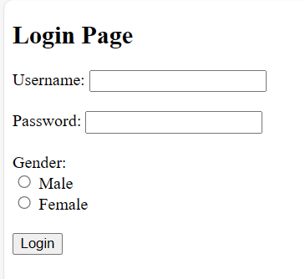

**7b. Write a javascript program for validating REGISTRATION FORM**

<!DOCTYPE html>

<html lang="en">

<head>

<meta charset="UTF-8">

<title>Registration Form</title>

<style>

.error {

color: red;

}

</style>

<script>

function validateRegistrationForm() {

var fields = ['username', 'email', 'password', 'confirm-password'];

var isValid = true;

fields.forEach(function(field) {

var value = document.getElementById(field).value.trim();

var errorElement = document.getElementById(field + '-error');

errorElement.textContent = value === '' ? capitalizeFirstLetter(field) + ' is required' : '';

if (field === 'confirm-password' && value !== document.getElementById('password').value.trim()) {

errorElement.textContent = 'Passwords do not match';

}

if (errorElement.textContent !== '') {

isValid = false;

}

});

return isValid;

}

function capitalizeFirstLetter(str) {

return str.charAt(0).toUpperCase() + str.slice(1);

}

</script>

</head>

<body>

<h2>Registration Form</h2>

<form onsubmit="return validateRegistrationForm()">

<div>

<label for="username">Username:</label>

<input type="text" id="username" name="username">

<span id="username-error" class="error"></span>

</div><br>

<div>

<label for="email">Email:</label>

<input type="email" id="email" name="email">

<span id="email-error" class="error"></span>

</div><br>

<div>

<label for="password">Password:</label>

<input type="password" id="password" name="password">

<span id="password-error" class="error"></span>

</div><br>

<div>

<label for="confirm-password">Confirm Password:</label>

<input type="password" id="confirm-password" name="confirm-password">

<span id="confirm-password-error" class="error"></span>

</div><br>

<input type="submit" value="Register">

</form>

</body>

</html>

**OUTPUT :**

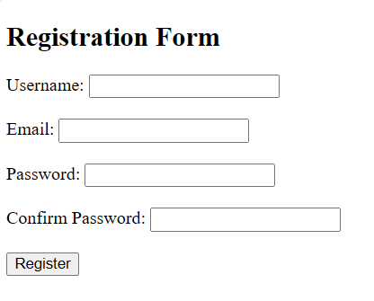

**8a.Write a program for implementing XML document for CUSTOMER DETAILS.**

<?xml version="1.0" encoding="UTF-8"?>

<customers>

<customer>

<id>1</id>

<name>John Doe</name>

<email>john.doe@example.com</email>

<phone>123-456-7890</phone>

<address>

<street>123 Main St</street>

<city>Anytown</city>

<state>CA</state>

<zipcode>12345</zipcode>

</address>

</customer>

<customer>

<id>2</id>

<name>Jane Smith</name>

<email>jane.smith@example.com</email>

<phone>987-654-3210</phone>

<address>

<street>456 Oak Ave</street>

<city>Somecity</city>

<state>NY</state>

<zipcode>54321</zipcode>

</address>

</customer>

</customers>

**OUTPUT :**

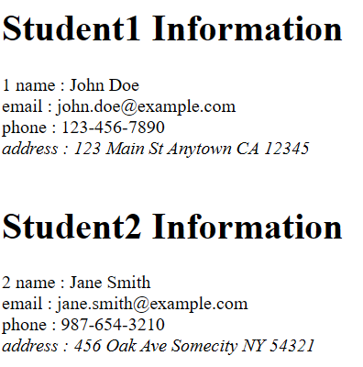

**8b. Write an internal Document Type Definition to validate XML for CUSTOMERDETAILS?**

<?xml version="1.0" encoding="UTF-8"?>

<!DOCTYPE customers [

<!ELEMENT customers (customer+)>

<!ELEMENT customer (id, name, email, phone, address)>

<!ELEMENT id (#PCDATA)>

<!ELEMENT name (#PCDATA)>

<!ELEMENT email (#PCDATA)>

<!ELEMENT phone (#PCDATA)>

<!ELEMENT address (street, city, state, zip)>

<!ELEMENT street (#PCDATA)>

<!ELEMENT city (#PCDATA)>

<!ELEMENT state (#PCDATA)>

<!ELEMENT zip (#PCDATA)>

]>

<customers>

<customer>

<id>1</id>

<name>John Doe</name>

<email>john.doe@example.com</email>

<phone>123-456-7890</phone>

<address>

<street>123 Main St</street>

<city>Anytown</city>

<state>CA</state>

<zipcode>12345</zipcode>

</address>

</customer>

<customer>

<id>2</id>

<name>Jane Smith</name>

<email>jane.smith@example.com</email>

<phone>987-654-3210</phone>

<address>

<street>456 Oak Ave</street>

<city>Somecity</city>

<state>NY</state>

<zipcode>54321</zipcode>

</address>

</customer>

</customers>

**OUTPUT :**



**8c. Write an external Document Type Definition to validate XML for CUSTOMERDETAILS?**

<?xml version="1.0"?>

<!DOCTYPE address SYSTEM "address.dtd">

<address>

<name>

<first>NAME:Rohit</first>

<last>Sharma</last> <br>

</name>

<email>EMAIL: sharmarohit@gmail.com</email> <br>

<phone>PHONE: 9876543210</phone> <br>

<birthday>

<year>DOB: 1987</year>

<month>June</month>

<day>23</day>

</birthday>

</address>

**OUTPUT :**

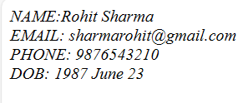

**9.Write an XML for person information and access the data using XSL.**

<!DOCTYPE html>

<html>

<head>

<title>Person Information</title>

</head>

<body>

<!-- XML Data -->

<persons>

<person>

<name>John Doe</name>

<age>30</age>

<email>john.doe@example.com</email>

</person>

<person>

<name>Jane Smith</name>

<age>25</age>

<email>jane.smith@example.com</email>

</person>

<person>

<name>Emily Johnson</name>

<age>35</age>

<email>emily.johnson@example.com</email>

</person>

</persons>

<!-- XSLT to transform XML Data -->

<script type="text/xsl" id="person-xsl">

<xsl:stylesheet version="1.0" xmlns:xsl="http://www.w3.org/1999/XSL/Transform">

<xsl:template match="/">

<html>

<head>

<title>Person Information</title>

</head>

<body>

<h1>Person Information</h1>

<table border="1">

<tr>

<th>Name</th>

<th>Age</th>

<th>Email</th>

</tr>

<xsl:for-each select="persons/person">

<tr>

<td><xsl:value-of select="name" /></td>

<td><xsl:value-of select="age" /></td>

<td><xsl:value-of select="email" /></td>

</tr>

</xsl:for-each>

</table>

</body>

</html>

</xsl:template>

</xsl:stylesheet>

</script>

<script>

document.addEventListener("DOMContentLoaded", function() {

// Get XML data

var xmlData = `

<persons>

<person>

<name>John Doe</name>

<age>30</age>

<email>john.doe@example.com</email>

</person>

<person>

<name>Jane Smith</name>

<age>25</age>

<email>jane.smith@example.com</email>

</person>

<person>

<name>Emily Johnson</name>

<age>35</age>

<email>emily.johnson@example.com</email>

</person>

</persons>

`;

// Parse the XML data

var parser = new DOMParser();

var xmlDoc = parser.parseFromString(xmlData, "text/xml");

// Get XSL data

var xslData = document.getElementById("person-xsl").textContent;

var xslDoc = parser.parseFromString(xslData, "application/xml");

// Transform XML using XSLT

if (window.ActiveXObject || "ActiveXObject" in window) {

// Code for IE

var ex = xmlDoc.transformNode(xslDoc);

document.body.innerHTML = ex;

} else if (document.implementation && document.implementation.createDocument) {

// Code for Chrome, Firefox, Opera, etc.

var xsltProcessor = new XSLTProcessor();

xsltProcessor.importStylesheet(xslDoc);

var resultDocument = xsltProcessor.transformToFragment(xmlDoc, document);

document.body.appendChild(resultDocument);

}

});

</script>

</body>

</html>

**OUTPUT :**

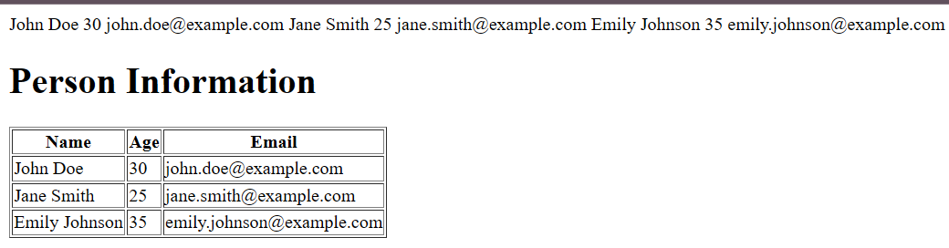

**10.Write an XML for student information and access second students data using DOM.**

<!DOCTYPE html>

<html>

<head>

<title>Student Information</title>

</head>

<body>

<h1>Student Information</h1>

<div id="student-info"></div>

<script>

// Define the XML data as a string

var xmlData = `

<students>

<student>

<name>John Doe</name>

<age>20</age>

<email>john.doe@example.com</email>

</student>

<student>

<name>Jane Smith</name>

<age>22</age>

<email>jane.smith@example.com</email>

</student>

<student>

<name>Emily Johnson</name>

<age>21</age>

<email>emily.johnson@example.com</email>

</student>

</students>

`;

// Parse the XML data

var parser = new DOMParser();

var xmlDoc = parser.parseFromString(xmlData, "text/xml");

// Access the second student's data

var secondStudent = xmlDoc.getElementsByTagName("student")[1];

var name = secondStudent.getElementsByTagName("name")[0].textContent;

var age = secondStudent.getElementsByTagName("age")[0].textContent;

var email = secondStudent.getElementsByTagName("email")[0].textContent;

// Display the second student's data in the HTML

document.getElementById("student-info").innerHTML = `

<h2>Second Student</h2>

<p><strong>Name:</strong> ${name}</p>

<p><strong>Age:</strong> ${age}</p>

<p><strong>Email:</strong> ${email}</p>

`;

</script>

</body>

</html>

**OUTPUT :**

